Tab 1
DATA SCAVENGER HUNT!
GOAL: Get accounts. Get familiar with data. Report back what you've found!

Define the following and/or provide examples:
--TLE, State Vector, Ephemeris, "observation", NORAD ID, COSPAR ID
TLE: A data format providing an approximate description of an Earth-orbiting object's orbital elements at a specific time. It's used for orbit propagation and changes with new observations.
State Vector: Data (position and velocity vectors or Keplerian elements) describing an object's orbital state at a specific time. Used in the Conjunction Prediction Challenge for orbit propagation.
Ephemeris: A data file or table listing the calculated positions of a celestial object over time.
“Observation”: A set of sensor measurements (e.g., range, angle) of a space object at a specific time. Uncorrelated observations can become UCTs.
NORAD ID: (North American Aerospace Defense Command Identifier) A unique 5-digit number assigned by NORAD to artificial satellites.
COSPAR ID: (Committee on Space Research Identifier) An international naming convention for satellites, including launch year and a launch number. Year, increment of launch (2024-106

--How many space launch complexes (SLCs) exist and are used globally?
Globally, there are roughly 23 to 35 active or capable spaceports and launch facilities for orbital and suborbital launches.

--What are the pros/cons of optical, radar, and RF observations?

 | Pros | Cons
Optical | High Res images for object characterization. Hard to detect because they collect light… no sent signal. Mature tech. Lower cost (ground based) | Weather and light dependant. Atmospheric distortion (blurry images), limited wavelengths because the atmosphere blocks some. Light pollution.
Radar | All weather, Day-night ops, cuts through weather. Can track many objects. Determines Range/velocity (distance and speed). Some systems can get the shape and motion of objects. | Lower resolution than optical. Expensive and complex. Interference from radio freq. Creates a detectable emission. Atmospheric attenuation??
RF | Analyzes signals to understand satellite ops, can help find objects not actively transmitting. Can locate RF signal sources. All-weather/day-Night, Offers global monitoring. Difficult to detect as it does not emit. | Requires objects to reflect the RF signal so it can track it. Crowded spectrum makes signal isolation hard. Can have interference with other RF sources. Does not provide high res-resolution images.

Get data from the Unified Data Library (UDL)
--https://unifieddatalibrary.com/

--Give me your UDL username - done

--We will give access to some data - done

--Fiddle with UDL to get all the data you can find on these objects - Done

Sample UDL Queries:

-- Launch Sites: https://unifieddatalibrary.com/udl/launchsite/

-- 18th SDS Two Line Element Sets from last 10 hours: https://unifieddatalibrary.com/udl/elset/count?epoch=%3Enow-10%20hours&source=18th%20SPCS

-- Notice to Space Operators (NOTSOs): https://unifieddatalibrary.com/udl/notification?createdAt=%3E2016-01-01T00:00:00.000Z&msgType=TACREP_NOTSO

Get data from space-track.org
--https://www.space-track.org/documentation

Get data from European Space Agency
--Create account
--https://discosweb.esoc.esa.int/

Explore orbits, plot/display things to find patterns
--https://spaceaware.io/
--https://spacecockpit.saberastro.com/

Explore UN Registry
--https://www.unoosa.org/oosa/osoindex/search-ng.jspx?lf_id=

Misc data sources:

--https://www.newspace.im/
--https://www.satcat.com/
--https://planet4589.org/
--https://space.skyrocket.de/
--https://dataverse.tdl.org/dataset.xhtml?persistentId=doi:10.18738/T8/NBWWWZ
--https://russianforces.org/blog/2013/01/status_of_the_russian_early-warning.shtml
--WARNING --> THIS IS RUSSIAN WEBSITE: http://mmt9.ru/
--http://www.satobs.org/seesat/index.html
--http://astria.tacc.utexas.edu/AstriaGraph/
--http://millstonehill.haystack.mit.edu/

Data Survey:
--Graph total number of payloads, rocket bodies, debris, and unknown objects on orbit in space-track.org or celestrak.com catalogs

Graph showing Number of Orbiting Objects by Type from space-track.org

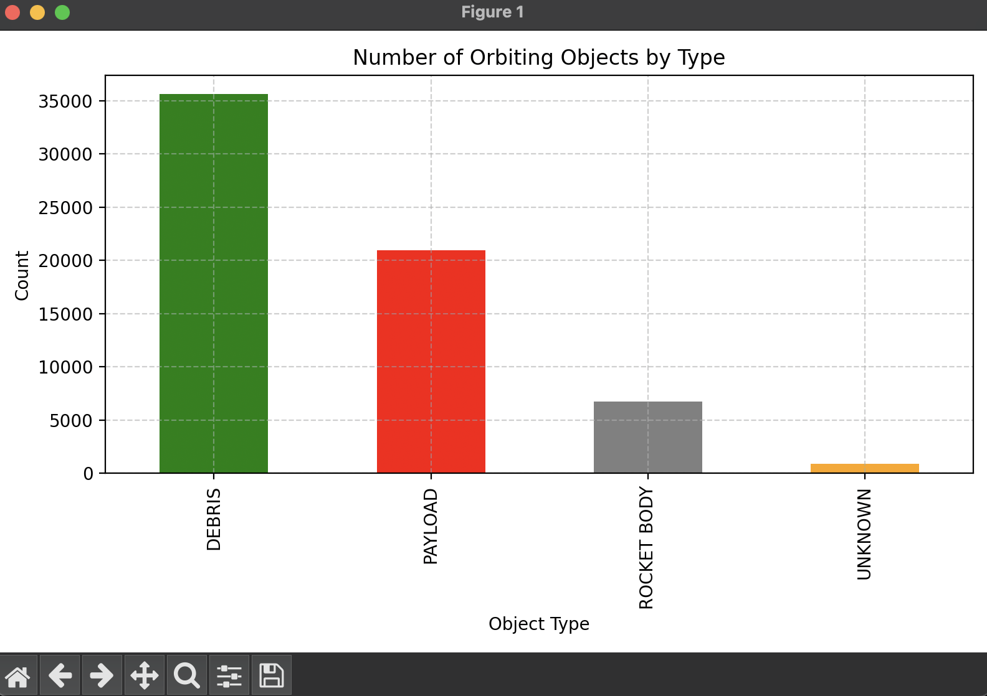
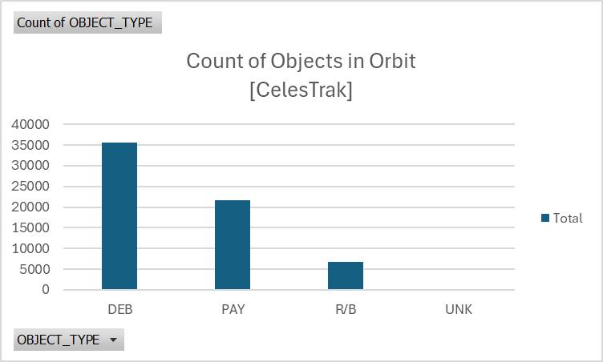
--Create similar stats from ESA catalog (discosweb), compare results (AVIEL IS ON IT)
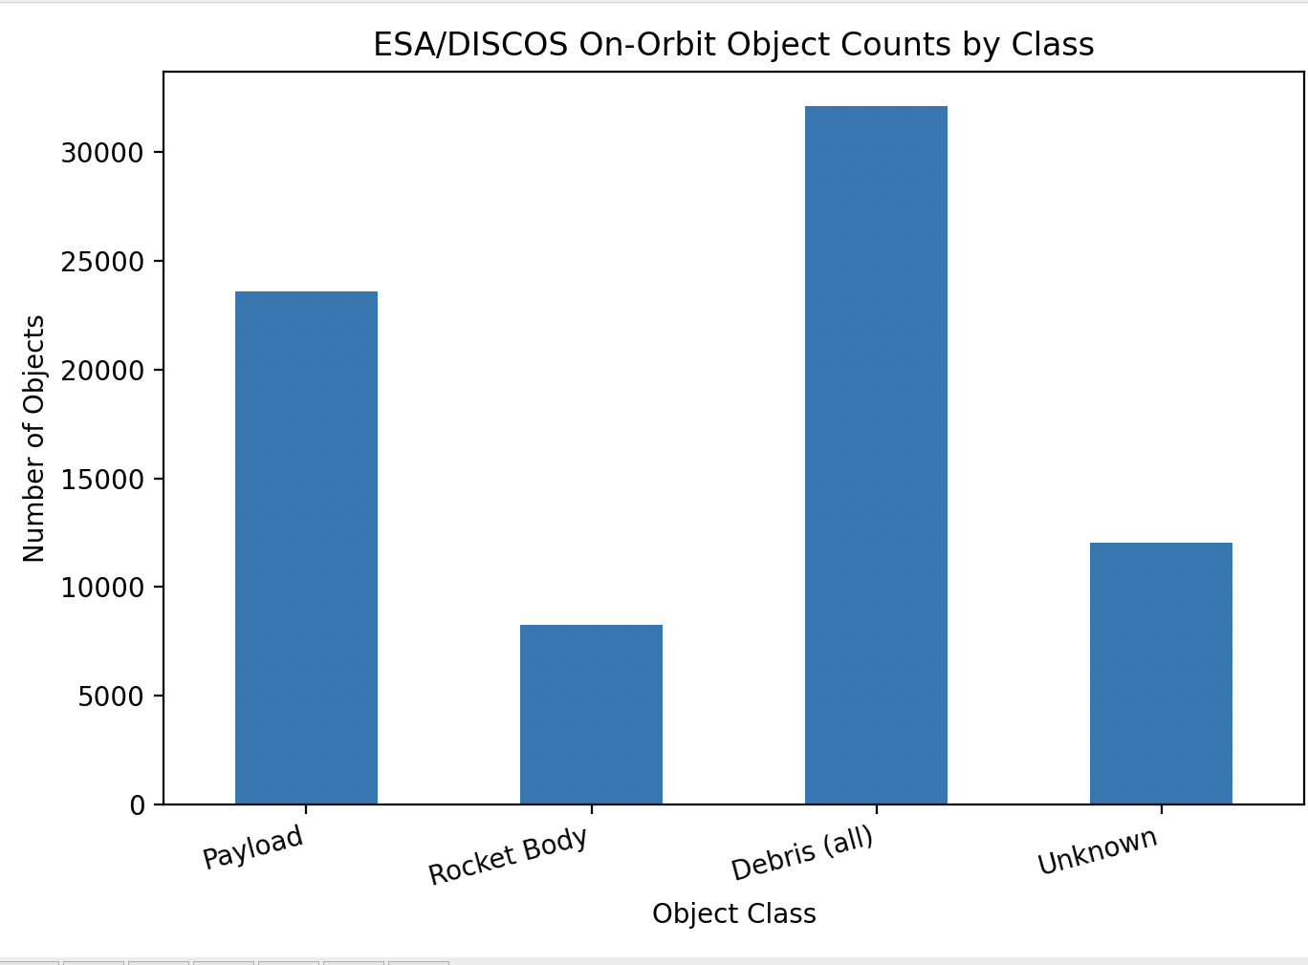
--Create a histogram of "eoobservations" for the last 1 year, split the series by "source" (ex: EXO, Cloudstone, Slingshot)

--Parse a TLE into fields/values
[Have code for this, not sure how to share it: Gabriel]

--Pick 5 random satellites, tell me what kinds of data are available commercially. Provide types, quantities, or other basic information

--Create a list of all satellites which have launched from a Soyuz 2.1a or Soyuz 2.1b from Plesetsk cosmodrome in Russia
DATA SCAVENGER HUNT (Complete) (way too long to give in another form)

--Identify at least one fragmentation event that is reported somewhere on the internet which is NOT reported by NASA Orbital Debris office
The Chinese navigation satellite Compass G2 experienced a fragmentation in 2016, reported in open sources yet absent from NASA ODPO’s records. swfound.org
The Atlas V second stage (Intl. Designator 2009-047B) fragmented around 25 March 2019, as tracked by Deimos Sky Survey but not included in NASA ODPO’s fragmentation history. deimos-space.com

Jim Shell - YASD

All Soyuz Satellites
WARNING: VERY LONG

COSMOS 309
COSMOS 313
COSMOS 317
COSMOS 328
COSMOS 329
COSMOS 333
COSMOS 353
COSMOS 361
COSMOS 364
COSMOS 376
COSMOS 383
COSMOS 384
COSMOS 396
COSMOS 401
COSMOS 403
COSMOS 424
COSMOS 427
COSMOS 430
COSMOS 438
COSMOS 439
COSMOS 442
COSMOS 443
COSMOS 454
COSMOS 456
COSMOS 464
COSMOS 470
COSMOS 477
COSMOS 478
COSMOS 483
COSMOS 484
COSMOS 486
COSMOS 488
COSMOS 490
COSMOS 495
COSMOS 502
COSMOS 503
COSMOS 512
COSMOS 515
COSMOS 518
COSMOS 522
COSMOS 525
COSMOS 527
COSMOS 538
COSMOS 541
COSMOS 548
COSMOS 550
COSMOS 552
COSMOS 554
COSMOS 555
COSMOS 556
COSMOS 559
COSMOS 560
COSMOS 561
COSMOS 563
COSMOS 575
COSMOS 576
COSMOS 577
COSMOS 578
COSMOS 579
COSMOS 584
COSMOS 587
COSMOS 596
COSMOS 597
COSMOS 598
COSMOS 600
COSMOS 602
COSMOS 603
COSMOS 605
COSMOS 607
COSMOS 612
COSMOS 616
COSMOS 625
COSMOS 629
COSMOS 630
COSMOS 635
COSMOS 639
COSMOS 640
COSMOS 649
COSMOS 653
COSMOS 657
COSMOS 659
COSMOS 664
COSMOS 666
COSMOS 669
COSMOS 671
COSMOS 688
COSMOS 690
COSMOS 692
COSMOS 693
COSMOS 694
COSMOS 696
COSMOS 697
COSMOS 704
COSMOS 709
COSMOS 720
COSMOS 721
COSMOS 728
COSMOS 730
COSMOS 741
COSMOS 742
COSMOS 743
COSMOS 746
COSMOS 747
COSMOS 748
COSMOS 751
COSMOS 753
COSMOS 757
COSMOS 758
COSMOS 759
COSMOS 769
COSMOS 771
COSMOS 776
COSMOS 779
COSMOS 782
COSMOS 784
COSMOS 788
COSMOS 805
COSMOS 810
COSMOS 811
COSMOS 813
COSMOS 815
COSMOS 820
COSMOS 821
COSMOS 833
COSMOS 834
COSMOS 840
COSMOS 844
COSMOS 847
COSMOS 848
COSMOS 854
COSMOS 855
COSMOS 857
COSMOS 863
COSMOS 867
COSMOS 892
COSMOS 896
COSMOS 897
COSMOS 898
COSMOS 902
COSMOS 905
COSMOS 907
COSMOS 912
COSMOS 915
COSMOS 916
COSMOS 922
COSMOS 927
COSMOS 934
COSMOS 935
COSMOS 936
COSMOS 938
COSMOS 947
COSMOS 948
COSMOS 949
COSMOS 950
COSMOS 953
COSMOS 958
COSMOS 964
COSMOS 969
COSMOS 974
COSMOS 984
COSMOS 987
COSMOS 988
COSMOS 993
COSMOS 995
COSMOS 1003
COSMOS 1004
COSMOS 1007
COSMOS 1010
COSMOS 1012
COSMOS 1022
COSMOS 1028
COSMOS 1029
COSMOS 1031
COSMOS 1032
COSMOS 1033
COSMOS 1042
COSMOS 1044
COSMOS 1046
COSMOS 1047
COSMOS 1049
COSMOS 1050
COSMOS 1059
COSMOS 1061
COSMOS 1068
COSMOS 1069
COSMOS 1070
COSMOS 1071
COSMOS 1073
COSMOS 1078
COSMOS 1079
COSMOS 1080
COSMOS 1095
COSMOS 1097
COSMOS 1098
COSMOS 1099
COSMOS 1102
COSMOS 1103
COSMOS 1106
COSMOS 1107
COSMOS 1108
COSMOS 1111
COSMOS 1115
COSMOS 1117
COSMOS 1118
COSMOS 1119
COSMOS 1121
COSMOS 1122
COSMOS 1123
COSMOS 1126
COSMOS 1127
COSMOS 1128
COSMOS 1129
COSMOS 1138
COSMOS 1139
COSMOS 1142
COSMOS 1144
COSMOS 1147
COSMOS 1148
COSMOS 1149
COSMOS 1155
COSMOS 1165
COSMOS 1166
COSMOS 1177
COSMOS 1178
COSMOS 1180
COSMOS 1182
COSMOS 1183
COSMOS 1185
COSMOS 1187
COSMOS 1189
COSMOS 1200
COSMOS 1201
COSMOS 1202
COSMOS 1203
COSMOS 1205
COSMOS 1207
COSMOS 1208
COSMOS 1209
COSMOS 1210
COSMOS 1211
COSMOS 1212
COSMOS 1213
COSMOS 1214
COSMOS 1216
COSMOS 1219
COSMOS 1221
COSMOS 1224
COSMOS 1227
COSMOS 1236
COSMOS 1239
COSMOS 1245
COSMOS 1262
COSMOS 1265
COSMOS 1273
COSMOS 1274
COSMOS 1276
COSMOS 1280
COSMOS 1281
COSMOS 1284
COSMOS 1296
COSMOS 1297
COSMOS 1301
COSMOS 1307
COSMOS 1309
COSMOS 1314
COSMOS 1318
COSMOS 1334
COSMOS 1338
COSMOS 1342
COSMOS 1343
COSMOS 1350
COSMOS 1353
COSMOS 1369
COSMOS 1376
COSMOS 1384
COSMOS 1385
COSMOS 1387
COSMOS 1396
COSMOS 1398
COSMOS 1401
COSMOS 1404
COSMOS 1406
COSMOS 1411
COSMOS 1422
COSMOS 1440
COSMOS 1444
COSMOS 1449
COSMOS 1451
COSMOS 1458
COSMOS 1462
COSMOS 1467
COSMOS 1468
COSMOS 1469
COSMOS 1472
COSMOS 1483
COSMOS 1485
COSMOS 1487
COSMOS 1488
COSMOS 1493
COSMOS 1495
COSMOS 1498
COSMOS 1499
COSMOS 1509
COSMOS 1511
COSMOS 1512
COSMOS 1514
COSMOS 1530
COSMOS 1537
COSMOS 1539
COSMOS 1543
COSMOS 1545
COSMOS 1549
COSMOS 1551
COSMOS 1557
COSMOS 1558
COSMOS 1572
COSMOS 1573
COSMOS 1575
COSMOS 1576
COSMOS 1582
COSMOS 1583
COSMOS 1584
COSMOS 1587
COSMOS 1590
COSMOS 1591
COSMOS 1592
COSMOS 1597
COSMOS 1609
COSMOS 1613
COSMOS 1628
COSMOS 1632
COSMOS 1647
COSMOS 1648
COSMOS 1653
COSMOS 1657
COSMOS 1659
COSMOS 1663
COSMOS 1664
COSMOS 1665
COSMOS 1667
COSMOS 1671
COSMOS 1672
COSMOS 1676
COSMOS 1678
COSMOS 1681
COSMOS 1683
COSMOS 1685
COSMOS 1705
COSMOS 1708
COSMOS 1713
COSMOS 1715
COSMOS 1730
COSMOS 1740
COSMOS 1742
COSMOS 1744
COSMOS 1746
COSMOS 1762
COSMOS 1768
COSMOS 1772
COSMOS 1789
COSMOS 1790
COSMOS 1819
COSMOS 1822
COSMOS 1826
COSMOS 1837
COSMOS 1846
COSMOS 1848
COSMOS 1863
COSMOS 1866
COSMOS 1872
COSMOS 1874
COSMOS 1886
COSMOS 1887
COSMOS 1893
COSMOS 1907
COSMOS 1915
COSMOS 1920
COSMOS 1923
COSMOS 1935
COSMOS 1938
FOTON 1
COSMOS 1951
COSMOS 1957
COSMOS 1967
COSMOS 1968
COSMOS 1973
COSMOS 1976
COSMOS 1983
COSMOS 1984
COSMOS 1990
COSMOS 2000
COSMOS 2003
COSMOS 2005
COSMOS 2006
COSMOS 2017
COSMOS 2018
FOTON 2
COSMOS 2019
RESURS F-1
COSMOS 2025
PION 1
PION 2
RESURS F-2
COSMOS 2029
COSMOS 2030
RESURS F-3
COSMOS 2032
COSMOS 2035
PION 3
PION 4
RESURS F-4
COSMOS 2036
RESURS F-5
COSMOS 2044
COSMOS 2047
COSMOS 2048
COSMOS 2052
COSMOS 2055
COSMOS 2057
COSMOS 2062
FOTON 3
COSMOS 2073
COSMOS 2077
COSMOS 2083
RESURS F-7
COSMOS 2086
COSMOS 2089
RESURS F-8
COSMOS 2099
RESURS F-9
COSMOS 2102
COSMOS 2104
COSMOS 2108
COSMOS 2120
COSMOS 2121
COSMOS 2124
COSMOS 2136
COSMOS 2138
COSMOS 2149
RESURS F-11
COSMOS 2152
RESURS F-12
RESURS F-13
FOTON 4
COSMOS 2171
COSMOS 2175
COSMOS 2182
RESURS F-14
COSMOS 2186
RESURS F-15
COSMOS 2203
COSMOS 2207
RESURS F-16
PION 5
PION 6
COSMOS 2210
FOTON 5
RESURS 500
COSMOS 2220
COSMOS 2229
COSMOS 2231
COSMOS 2240
RESURS F-17
RESURS F-18
COSMOS 2259
COSMOS 2260
RESURS F-19
COSMOS 2281
FOTON 9
FOTON 10
RESURS F-10
COSMOS 2511
COSMOS 2505
COSMOS 2495
COSMOS 2480
COSMOS 1105
COSMOS 1978
COSMOS 2462
COSMOS 1969
COSMOS 1965
COSMOS 1942
COSMOS 2450
COSMOS 2445
COSMOS 1841
COSMOS 2427
COSMOS 1813
COSMOS 1807
COSMOS 1757
COSMOS 2420
COSMOS 2410
COSMOS 2387
COSMOS 2377
FOTON 12
COSMOS 2365
COSMOS 2358
COSMOS 2348
BION 11
COSMOS 2331
COSMOS 2314
COSMOS 1599
COSMOS 2311
COSMOS 1580
COSMOS 2283
COSMOS 1568
COSMOS 1505
COSMOS 1497
COSMOS 1442
COSMOS 1332
COSMOS 1283
COSMOS 1152
COSMOS 2551
COSMOS 1248
COSMOS 1824
COSMOS 1956
COSMOS 1981
COSMOS 2156
COSMOS 2274
MERIDIAN 1
COSMOS 2521
COSMOS 2525
COSMOS 2519
COSMOS 865
COSMOS 2472
COSMOS 1237
COSMOS 1765
COSMOS 2542
COSMOS 2562
COSMOS 1090
COSMOS 1407
COSMOS 1454
COSMOS 1471
COSMOS 1496
COSMOS 1532
COSMOS 1548
COSMOS 1645
COSMOS 1649
COSMOS 1699
COSMOS 1702
COSMOS 1706
COSMOS 1724
COSMOS 1734
COSMOS 1847
COSMOS 1882
COSMOS 1906
RESURS F-6
RESURS F-20
FOTON 11
RESURS F-1M
RESURS F-1M
COSMOS 2568
COSMOS 2543
COSMOS 2580
COSMOS 2503
COSMOS 2455
COSMOS 2493 (SKRL 756)
COSMOS 2494 (SKRL 756)
COSMOS 2512
COSMOS 2441
COSMOS 2486
COSMOS 2502
COSMOS 2506
COSMOS 2523
COSMOS 2524
COSMOS 2528
COSMOS 2549
COSMOS 2550
COSMOS 2554
COSMOS 2565
COSMOS 2566
COSMOS 2571
COSMOS 2573
AIST 1
COSMOS 2556
COSMOS 2567
COSMOS 2515
COSMOS 2579
COSMOS 2581
COSMOS 2561
COSMOS 2582
COSMOS 2583
COSMOS 2558
COSMOS 2570
COSMOS 2572
COSMOS 2574
COSMOS 2575

